DATA ANALYSIS REPORT
Study Location & Study Experience

Understanding how study environments shape student productivity

Survey-based Analytics | 83 Respondents | 17 Variables

Overview
This report presents a data-driven analysis of how study location affects the productivity of students. A survey was conducted and got responses from 83 students, primarily B.Tech undergraduates, to understand their study habits, preferred study locations, productivity levels, and factors influencing their study environment choices.
The analysis covers exploratory data analysis across nine focus areas, including demographics, study behaviour, productivity patterns, distraction analysis, library usage, and exam behaviour. A machine learning classification model was also built to predict a student's primary study location based on their habits and productivity ratings.

1. Introduction

1.1 Idea
The idea for this project came from a observation: large number of students complain about low productivity, yet most of them continue studying in the same distracting environments every day. The library is available, often underused, and students understand that it might be better to use library but they don't go. Why?
This project tries to put numbers to that behaviour and understand it through data.

1.2 Objectives
- To examine where students mainly study and why.
- To find out how students assess their productivity in different locations.
- To pinpoint the factors that most affect distraction and productivity.
- To explore how students use the library and the challenges they face.
- To create a machine learning model that predicts a student's main study location.
- To display all findings in an interactive dashboard.

2. Data Collection

2.1 Survey Design
The Google form survey was utilized for collecting information about students' studying habits. The form included several aspects of students' studying behavior, including not only their location while studying but also the frequency, amount of time spent, distractions, and productivity within that particular environment.
These were the topics covered by the survey's 17 questions:
- Demographics — academic program, year of study, gender
- Study habits — primary location, library usage frequency, daily study hours, study routine
- Productivity ratings — self-rated productivity at hostel, library, and classroom (scale of 1 to 5)
- Distractions — how easily get distracted, top distractors (multi-choice)
- Library behaviour — reasons for going to or avoiding the library
- Exam behaviour — change in study intensity and location during exams

2.2 Data Collection Details
Method | Online Google Form Survey , self-reported
Total Responses | 83 students
Responders | College students (primarily B.Tech)
Question Types | Multiple choice, Rating scale (1-5), Multi-select
Total Variables | 17 columns (after cleaning)

The survey was shared through whatsapp and filled voluntarily by students, responses are self reported ,and were completely anonymous.

3. Data Cleaning & Preprocessing
The data that was collected from the Google Form contained headers for columns as well as responses that were not formatted uniformly. Before the data analysis process could start, various kinds of cleaning needed to be performed on the data.

3.1 Column Renaming
Columns in Google Forms have their questions as names. These names were too lengthy and difficult to work with when coding. Thus, all of the 17 columns were renamed into short, clean snake_case names.
For example:
- " Where do you usually study? (Primary location) " → primary_location
- " Rate your productivity... [Home/Hostel]" → productivity_home
- "Do you get easily distracted while studying?" → easily_distracted

3.2 Response Value Standardisation
Several answer values were also cleaned up to make them shorter and more consistent for analysis and visualisation:
Column | Before → After
year | "1st Year" → "Year 1", "Final Year(M. Tech / M. Sc)" → "Final Year"
primary_location | "Hostel Room" → "Hostel"
library_usage | "Yes, regularly" → "Regularly"
daily_study_hours | "Less than 2 hour" → "<2 hrs", "2–4 hours" → "2-4 hrs"
exam_study_intensity | "Yes, significantly more" → "Significantly more"
exam_location_change | "Yes → I prefer library" → "Yes - Library"

3.3 Handling Productivity Ratings
If a student chose "Not my study spot (yet)" as one of his or her spots, the value was assigned 0 instead of leaving it as a string or NaN. After that, the data was transformed into numeric type via pd.to_numeric() function. It makes it possible to perform mathematical operations such as calculating averages without mistaking "not applicable" for a real value.
.

3.4 Feature Engineering
One new column was derived from existing data:
- avg_productivity — the mean of productivity_home, productivity_library, and productivity_class for each student. This gives a single overall productivity score per student and is used in correlation analysis and model building.

4. Exploratory Data Analysis
The exploratory data analysis (EDA) process was carried out for nine distinct focus areas. The focus areas make use of visualizations and summary statistics in order to gain insights from the dataset. All the visualizations were plotted using Matplotlib, Seaborn, and Plotly.

4.1 Demographics
This section discusses the demographic characteristics of the respondents based on their academic programs, level of education, and gender.

Visualisation
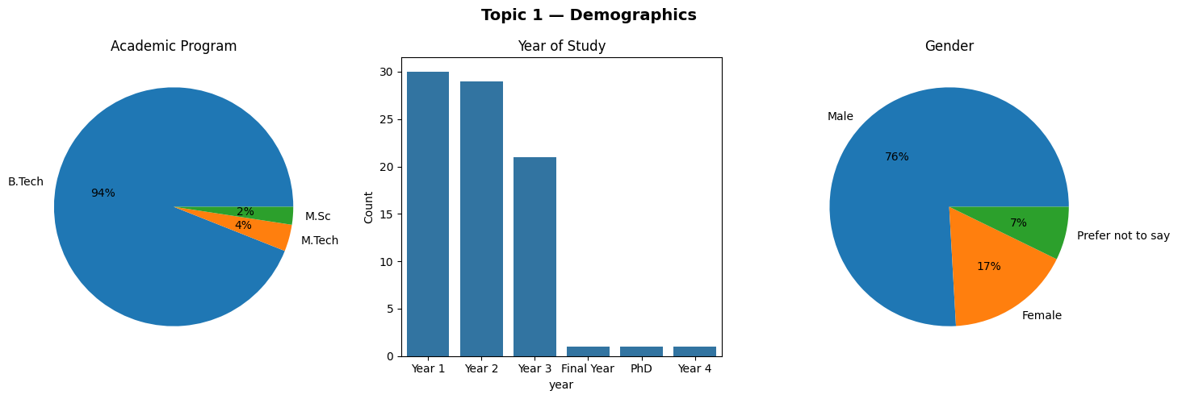

Observations
- 94% are B.Tech students, with just a minority of M.Tech and M.Sc.
- 72% belong to Year 1 and Year 2, skewing the data in favor of the juniors.
- 76% are males, while 17% are females and the remaining 7% chose not to reveal their gender identity.

4.2 Study Behaviour overview
This section examines the foundational study habits of students — where they study, how often they use the library, how many hours they study in daily, and whether they follow a fixed routine.

Visualisation
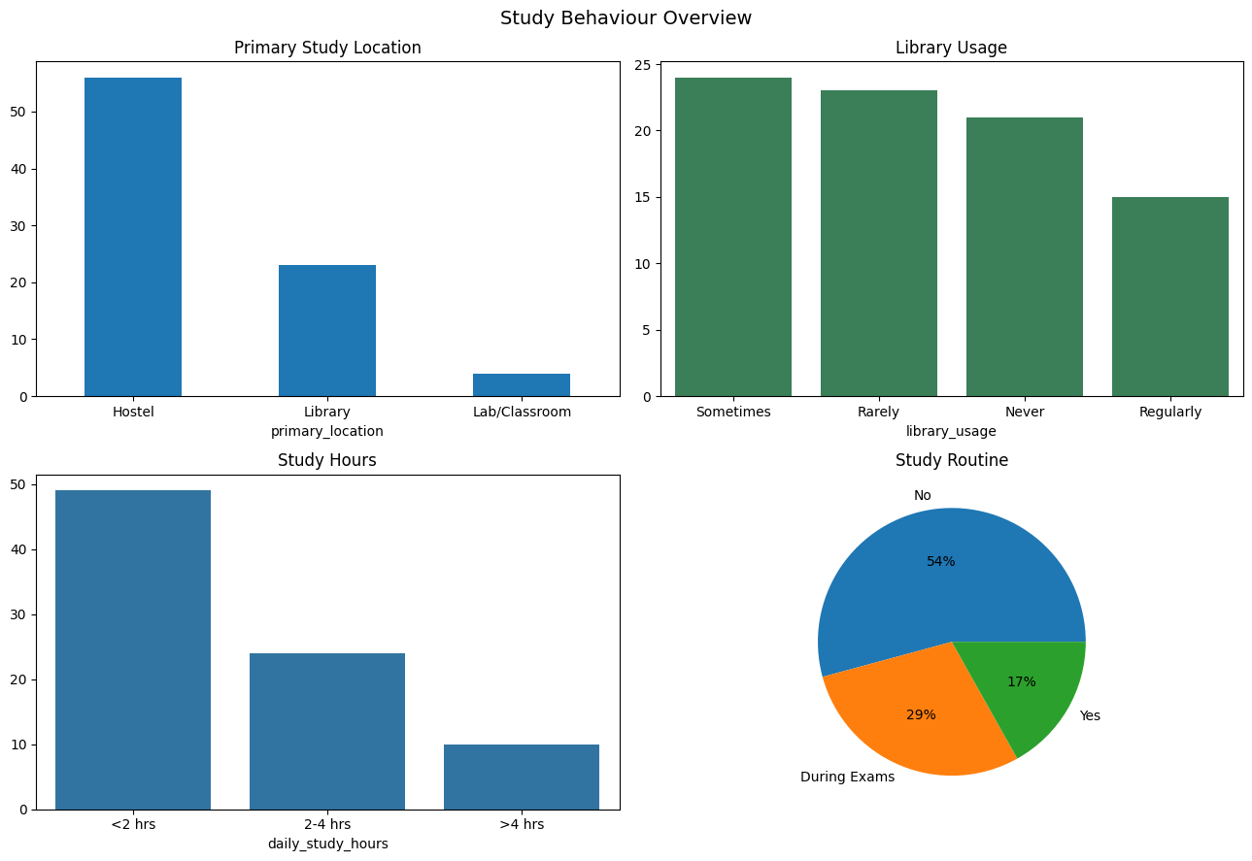

Observations
- 67.5% of students mostly study at Hostel.
- Only 18% are frequent visitors of library - while the rest of 82% use it occasionally or even never.
- 59% students study for less than 2 hours daily, 29% study from 2 to 4 hours and just 12% more than that.
- 54% students have no regular routine of study, 29% follow study routine just during exam period and 17% always.

4.3 Productivity Ratings by Location
Students were asked to rate their productivity at each of three locations on a scale of 1 to 5 (1 = Very Low, 5 = Very High). Students who do not use a particular location marked it as "not my study spot" which was recorded as 0.

Visualisation

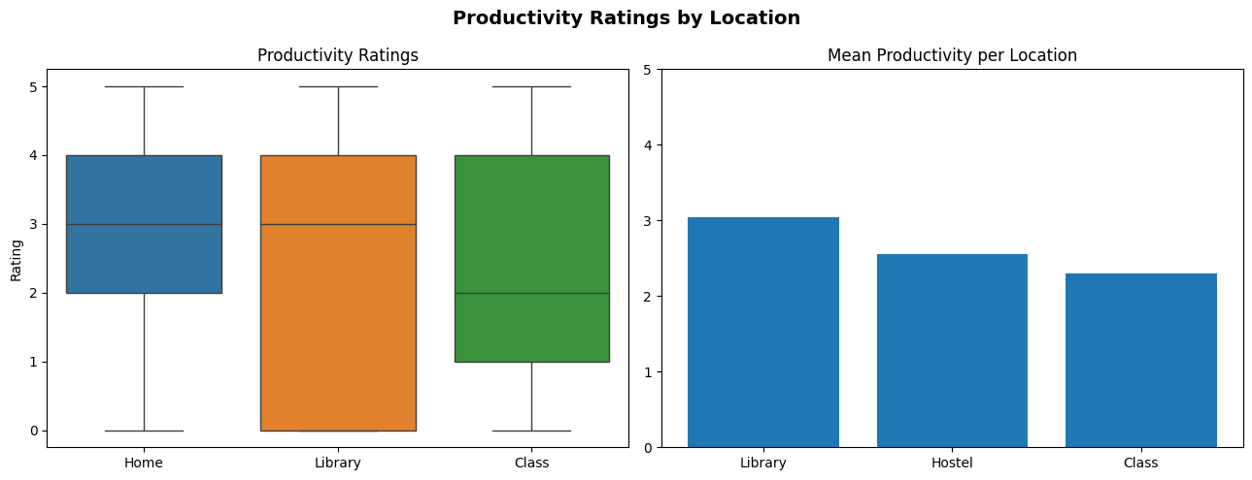

Statistical Summary
Location | Mean Rating
Library | ~3.
Hostel | ~2.5
Class / Lab | ~2 (lowest)

Observations
- Library scores the highest mean productivity at approximately 3 out of 5.
- Hostel comes second at approximately 2.5, and Class/Lab scores the lowest at 2.
- 0 values (not my spot) slightly pull the averages down — actual ratings among users are likely higher.

Interpretation
Despite library having the highest productivity score, most students do not study there regularly. This gap between the best-rated space and the most-used space is one of the central findings of this project — students are not studying where they feel most productive.

4.4 Primary Location vs Productivity

Visualisation

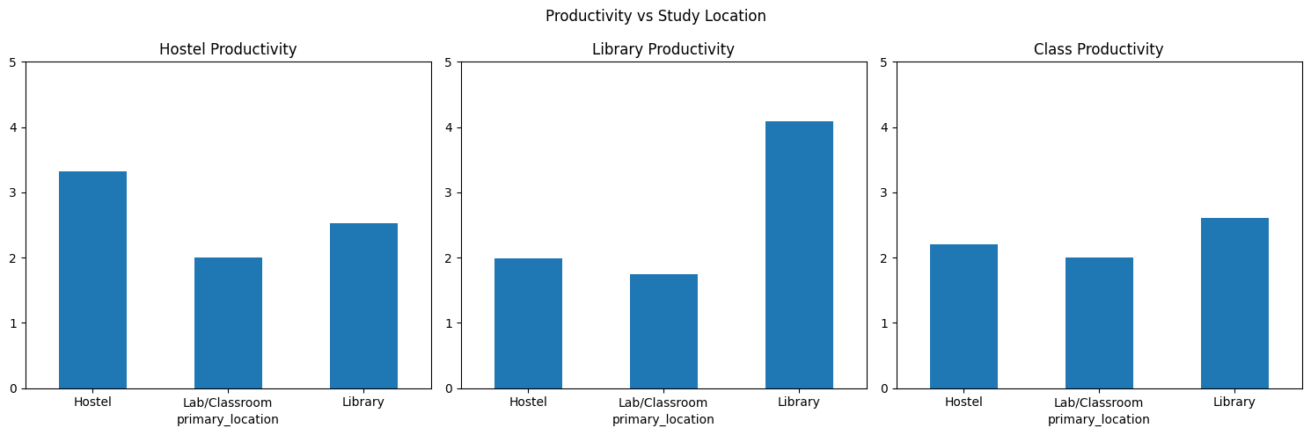

Observations
- Students consistently rate their own preferred location the highest.
- Hostel students rate hostel productivity highest; library students rate library productivity highest.
- Even hostel students give the library a reasonably decent rating — they knows it works.
- Lab/Classroom receives low ratings across all student groups regardless of their primary location.

Interpretation
There is a clear comfort bias in the data. Students feel more productive where they are already used to studying — not necessarily where they would objectively perform best

4.5 Distraction Analysis
Distractibility is another important variable that could influence productivity. In this part, the extent of distractibility among students, their causes of distraction, and variation in distractibility according to study environments are analyzed.

Visualisation

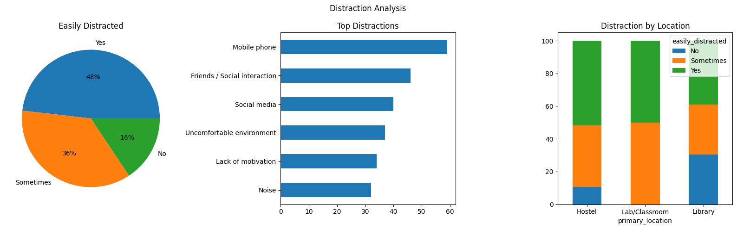

Observations
- 48% claimed to be easily distractible, 36% sometimes, while only 16% remain undistracted.
- Therefore, 84% of all students experience distraction to some extent when studying.
- Mobile phones and social media are the top distractors by a large margin.
- Hostel students face the highest distraction levels, library students the least.

4.6 Patterns of Library Use
Since the library ranks highest when it comes to productivity, it is crucial to know why people choose the library as well as why most others do not use it.

Visualisation
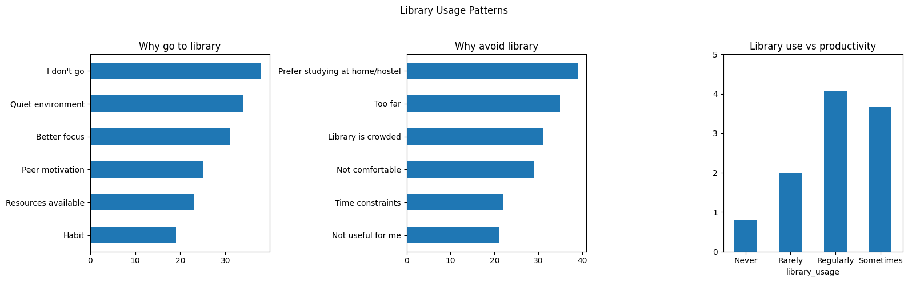

Observations
- Most common reason for using the library: concentration, quiet environment, less distractions, group studying.
- Most common reason for not using the library: preference for hostel, busy library, problems related to time and location.
- Consistent users of the library find themselves more productive in the library setting.
- Library avoidance seems to be the product of habits and comfort rather than dissatisfaction with the library.

4.7 Exam Behaviour
Exam season is period when most of the students start studying or increase their study intensity . This section checks how the Exam periods changes the study intensity of student and their study Locations

Visualisation

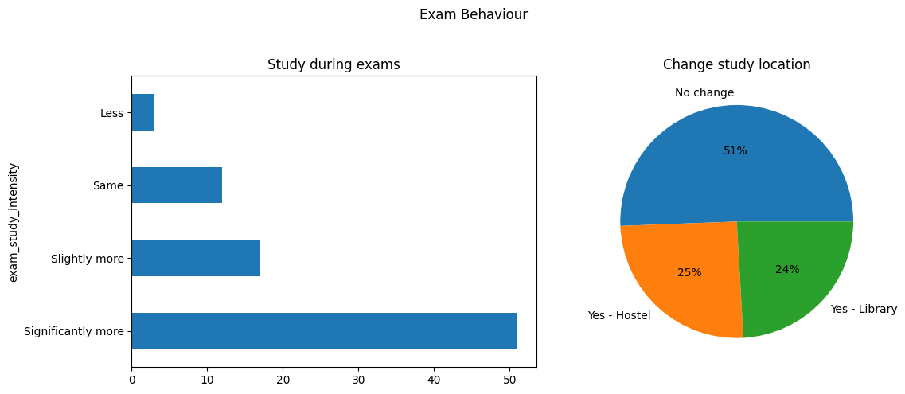

Observations
- 61% study significantly more during exams, and 20% study slightly more — so 81% increase effort.
- 51% do not change their study location even during exams.
- Exam pressure drives an increase in study hours but not necessarily a change in environment.
- It also shows that students who normally avoid the library do consider it during exams.

4.8 Correlation Analysis
To understand relationships between the numeric and ordinal variables in the dataset, ordinal encoding was applied to categorical variables and correlation heatmap was generated. Variables included in the heatmap are: year, library usage, study hours, study routine, productivity at home, library, and class, average productivity, and distraction level.

Visualisation
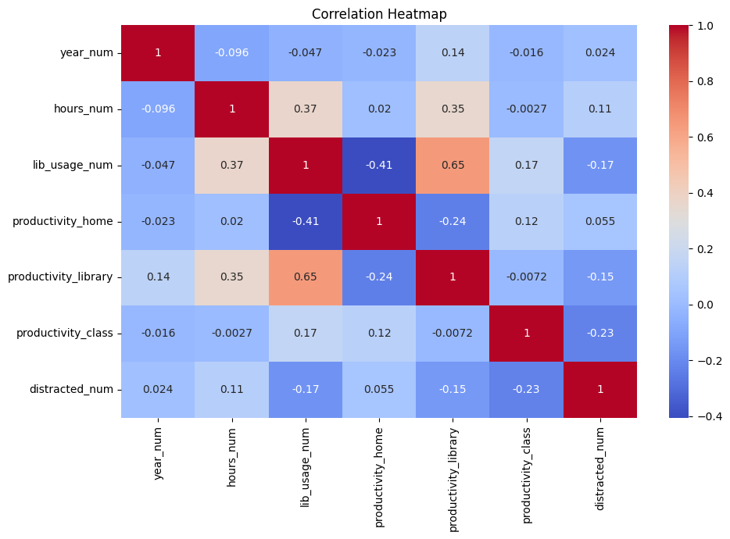

Observations
- Library usage and library productivity show a positive correlation — students who visit more often feel more productive there.
- Study hours have a mild positive relationship with overall productivity across all locations.
- Distraction level does not show a strong correlation with productivity ratings — a somewhat surprising result.
- Study routine shows a weak positive link with productivity — having a routine helps slightly but is not the dominant factor.
- No single variable strongly predicts productivity on its own.

Interpretation
Productivity is not driven by any one variable in isolation. It emerges from a combination of environment, habit, and personal discipline.

5. Machine Learning Model

5.1 Goal
The objective behind using the model is to determine the place where the learner is most likely to study; that is, whether at the Hostel/Library or Classroom.
.

5.2 Features Used
The following variables were used as input features to the model:
Feature | Description
year_num | Year of study (encoded 1 to 6)
hours_num | Daily study hours (encoded 1 to 3)
lib_usage_num | Library usage frequency (encoded 1 to 4)
routine_num | Study routine (encoded 1 to 3)
distracted_num | Ease of distraction (encoded 1 to 3)
productivity_hostel | Numeric productivity rating at hostel
productivity_library | Numeric productivity rating at library
productivity_class | Numeric productivity rating at class

5.4 Models Trained
- Logistic Regression
- Random Forest Classifier — an non - linear model that also provides feature importance
A train/test split of 80/20 was used. Cross-validation with 3 folds was applied due to the small dataset size to get a more reliable accuracy estimate.

5.5 Results
Metric | Logistic Regression
Overall Accuracy | 76%
CV Accuracy (3-fold) | 83% (+/- 0.05)

Both Logistic Regression and Random Forest gave identical accuracy (76%), which is reasonable for a dataset of 83 students. Cross-validation gave a more stable estimate of 83%.

5.6 Feature Importance

The feature importance scores from the Random Forest model ranked variables in the following order:
Rank | Feature
1 | Library Usage
2 | Productivity at Hostel
3 | Productivity at Library
4 | Study Routine
5 | Productivity at Class
6 | Distraction Level
7 | Study Hours
8 | Year of Study

The use of library is the Most Important predictor in deciding the location choice of the student; it explains almost a third of the prediction capability of the model. It makes perfect sense when you consider that, just like the EDA results, frequent library use is the strongest predictor of the location being a library.

5.8 Model Limitations
- Dataset has only 83 samples — a larger dataset would give much more reliable results.
- Lab/Classroom option has only 4 samples; thus, learning from this variable becomes very difficult for the model.
- The model predicts behavioural tendency based on self-reported data, not objectively measured output.

6. Key Findings
The following are the most important takeaways from the entire analysis:

- 67.5% of students prefer studying at Home/Hostel, despite the library being the most productive location as far as perception goes.
- 84% of students get distracted when studying, the two biggest reasons being mobile phone use and social media interaction.
- Students show a comfort bias — they consistently rate their own preferred location higher than others, regardless of which location is objectively better.
- Library usage is the most influential factor affecting study place preference (importance value of 0.31).
- Respondents who use the library find it more productive, thus validating the existence of the positive feedback mechanism.
- 81% of respondents study harder in examinations periods, but 51% keep using the same places they used before – increasing efforts but not changing environments.
- It seems that Third Year students use Library more Often and more productively than first year and second year students.
- No single variable strongly predicts productivity — it is shaped by a combination of environment, routine, study hours, and personal discipline.

8. Limitations
- Sample size of 83 student is small which limits the analysis.
- The sample is 94% B.Tech and 76% male — it does not represent the full diversity of the student population.
- Data is entirely self-reported, meaning productivity ratings reflect perception rather than actual output.
- Data was collected during a particular point of time in a semester and cannot track changes in habits over a semester or year.

9. Conclusion
Students who study in the library feel more productive there. The library is quieter, has fewer distractions. Yet the majority of students still default to studying at hostel , even though they know the library might serve them better.

